*School of Computing*

**CC6001**

**Advanced Database Systems Development**

**WORKSHOP 1**

**ORACLE SQL Revisited**

**1. INTRODUCTION**

ORACLE is a Relational Database Management System (RDBMS). As such, the only data structure that it supports is the TABLE. A Table is simply a two-dimensional matrix with horizontal ROWS and vertical COLUMNS. Readers may be interested to note that a RDBMS is an implementation of Codd's Relational Data Model and that in the literature on relational topics certain items are often slightly different. In particular, our Tables are called RELATIONS, our rows are called TUPLES and our columns are called ATTRIBUTES.

ORACLE has one language to handle both definition and manipulation of the data. Furthermore, this same language also deals with Security aspects.

This language is called SQL (Often referred to as SeQueL or Structured Query Language). Although the trend is to provide the user of ORACLE applications with higher level user-interfaces (e.g. Forms based application screens) where no knowledge of SQL is necessary, it is essential that anyone involved in the development of ORACLE applications has a thorough grounding in SQL.

People registered as ORACLE users will obviously wish to create and manipulate their own Tables. However, the approach taken by this introductory text will be to concentrate initially on the retrieval aspects of SQL. In particular, we will consider retrieval operations on some sample tables to which all users have been granted read-only access. The sample tables are **EMP, DEPT, SALGRADE** are described in Appendix 1.

Readers wishing to define and manipulate their own tables are advised to read Chapters 7 and 8. This introductory text should be used as a manual and therefore you should not attempt to work through it in sequence. An initial read through is recommended so that you get an idea of the range of features available, after that use the manual for reference purposes on**3. THE SAMPLE TABLES**

Note: These are the sample tables which ORACLE comes with - there may be differences in the some of the data values.

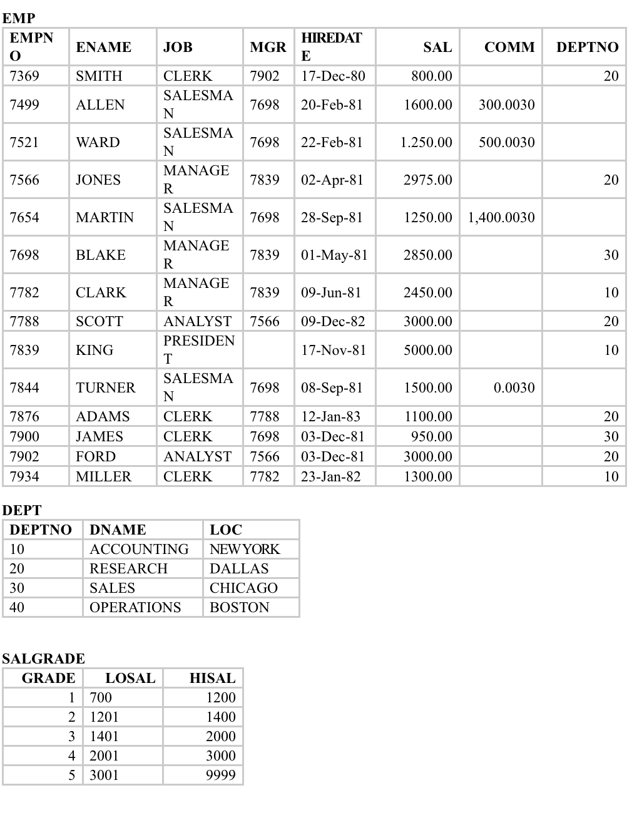

**Workshop (Exercises 1) - Basic Querying of Database**

* Log on to the SQL Developer
* Pull down each menu and look at the options
* Create the sample tables by running Demo Build file.
* Formulate and evaluate the following queries in SQL. The queries are based on the sample tables referred to on the previous page.

**For tutorial/examples of SQL, please refer to appropriate textbooks recommended in the module bibliography and Oracle SQL Booklet.**

**Retrieval from a single table**

1. List details of employees in departments 10 and 30.
2. Display all employees who were recruited during 1983, giving their name, department and hire date.
3. List the employees whose names have TH or LL in them.
4. List the department numbers and names in department name order.

**Retrieval from multiple tables (Joining tables)**

1. Display employee name, location and department name of those whose salary is between 1000 and 2000.
2. Find the name and salary of employees in Dallas.
3. List all the employees and their manager number.
4. As in Q3 but list manager's name as well as his number.
5. As in Q3 but include those employees that do not have a manager.
6. List the employee's name and salary and the manager's name and salary for all employees who earn more than their manager.
7. List employee name, job, salary and grade for those in grade 3.

**Workshop (Exercises 2) - More Querying of Database**

Formulate and evaluate the following queries in SQL. The queries are based on the Company database which is referred to in the manual.

**Handling data types**

1. List the maximum and minimum salary for each job type.
2. For each salesman, list his name, salary, commission, and percentage commission of salary.
3. Find all salesman whose commission is greater than 5% of their salary.
4. Print the employee name and hire date as 'Month day, four-digit year' for employees in department 30.
5. Find how many managers there are without listing them.
6. Find the names, jobs, salaries and commissions of all employees who do not have managers.